

Federal Grant Davis-Bacon Act Compliance &
Prevailing Wage Compliance for SMUD contractors and subcontractors

Please refer to the following documentation to demonstrate Davis-Bacon Act compliance:
1. Summary of Requirements Template- all contractors and subcontractors are required to submit this to SMUD. It should be completed and submitted as soon as the project scope of work has been defined. This document will be submitted to the granting agency for prevailing wage approval. Information from the California Energy Commission for receiving wage rate approval is attached.
2. Weekly Certified Payroll: Workers covered by Davis-Bacon Act must be paid weekly. Employers of all workers that are covered by Davis-Bacon Act and California prevailing wage must submit weekly certified payroll documents. Per 29 CFR 5.5, requirements include: “The payrolls submitted shall set out accurately and completely all of the information required to be maintained under 29 CFR 5.5(a)(3)(i), except that full social security numbers and home addresses shall not be included on weekly transmittals. Instead the payrolls shall only need to include an individually identifying number for each employee ( e.g. the last four digits of the employee's social security number). The required weekly payroll information may be submitted in any form desired. Optional Form WH–347 is available for this purpose from the Wage and Hour Division Web site at http://www.dol.gov/esa/whd/forms/wh347instr.htm or its successor site.” Employers may use the attached Department of Labor WH-347 form and instructions to prepare weekly certified payrolls for the duration of the work. Certified Payroll documents are to be submitted to SMUD in care of Bob Hollowell at bhollow@smud.org or (916) 732-6451
3. Prevailing Wage Bid Rates: contractors may refer to the separate worksheet at this site to make preliminary job estimates using prevailing wage rate determinations for work being proposed. The rates are current with the published date and are subject to change. The work bid date or start date determines which rates apply. Use these rates to submit with scopes of work for formal wage determinations submitted in item 1, above. Please note: all wage determinations depend on an accurate description of the work being done. This worksheet applies known labor categories to known types of work; however, other categories may also apply for work being proposed, such as helpers, laborers and apprentices.
4. Primary point of contact at SMUD for all matters pertaining to federal grant Davis-Bacon Act wages and California Prevailing Wages is Frank Martinez. Contact him at: fmartin@smud.org or (916) 732-5604.

Obtaining Prevailing Wage Rate Approvals
As stated in the terms and conditions of your American Recovery and Reinvestment Act of 2009 (ARRA) award agreement (agreement), all ARRA funding Recipients (Recipients) entering into subcontracts or providing subsidies for retrofit services1 to complete the objectives of their agreements must submit each such subcontract and applicable prevailing wage determination(s) to their assigned Commission Agreement Manager (CAM). The Energy Commission will review the information and, where prevailing wage rates apply, approve the Recipient to begin work under such subcontracts at specified labor and benefit rates. No work under such subcontracts can begin until the Energy Commission provides this written approval. In order to expedite the Energy Commission’s review and approval, Recipients should submit the following information in electronic format to your CAM:
- A summary of the prevailing wage information necessary for the Energy Commission’s review and approval. A summary template containing the required minimum information can be found at http://www.energy.ca.gov/recovery/documents/index.html#wage.

- Copies of all lower tier subcontracts for services to complete the objectives of the agreement (subcontracts).
- Copies of any terms and conditions or other documents that create and implement a rebate or subsidy for multi-family or commercial retrofits.

- The applicable federal wage determination issued by the United States Department of Labor (DOL) for the county in which the work is to be performed, which can be located at http://www.wdol.gov/Index.aspx.

- The applicable California wage determination issued by the California

- Department of Industrial Relations (DIR) for the county in which the work is to be performed, which can be located at http://www.dir.ca.gov/dlsr/DPreWageDetermination.htm.
- List of applicable job classifications—as issued by DOL and/or DIR—and corresponding rate(s) to be used under each subcontract. Please note that you can either provide separate labor and benefit rates for each listed classification or provide a loaded hourly rate. If you provide a loaded hourly rate, then you must indicate that fringe benefits are included in the stated amount.

- A brief description of your proposed project activities (i.e., the project description
  - that you are providing to subcontractors commonly referred to as the Scope of Work) that indicates the county in which the work is to be performed.
___________________________________
1 Retrofit services do not include subcontracts or subsidies for energy audits.
Page 1 of 2

- A brief description of the job duties to be performed by each individual employed under each subcontract, which includes each individual’s job title and journeyman status.

- If you are using apprentices or trainees, you must provide documentation that each apprentice or trainee is registered in an approved apprenticeship2 or training program.3 In addition, you must include the percentage (%) of the basic hourly rate required or fringe benefits specified in the approved apprenticeship or training program in accordance with the individual’s level of progression, and the allowable ratio of apprentices/trainees to journeymen specified in the approved program.

- Copies of any conformance requests that have already been submitted to DOL for proposed job classifications to be used on your project. (Please note that the proper procedure for making a conformance request is for the Recipient or their subcontractor to submit a conformance request to the Energy Commission, which will, in turn, forward the request to DOL.)

If you have any questions regarding the process outlined above, please contact the Energy Commission’s DBA Contracting Officer, Michelle Tessier, at (916) 653-9662.

____________________
2 29 C.F.R. § 5.2(n)(1) (“Apprentice means (i) a person employed and individually registered in a bona fide apprenticeship program registered with the U.S. Department of Labor, Employment and Training Administration, Office of Apprenticeship Training, Employer and Labor Services, or with a State Apprenticeship Agency recognized by the Bureau, or (ii) a person in the first 90 days of probationary employment as an apprentice in such an apprenticeship program, who is not individually registered in the program, but who has been certified by the Office of Apprenticeship Training, Employer and Labor Services or a State Apprenticeship Agency (where appropriate) to be eligible for probationary employment as an apprentice.”).
3 29 C.F.R. § 5.2(n)(2) (“Trainee means a person registered and receiving on-the-job training in a construction occupation under a program which has been approved in advance by the U.S. Department of Labor, Employment and Training Administration, as meeting its standards for on-the-job training programs and which has been so certified by that Administration.”)

Page 2 of 2
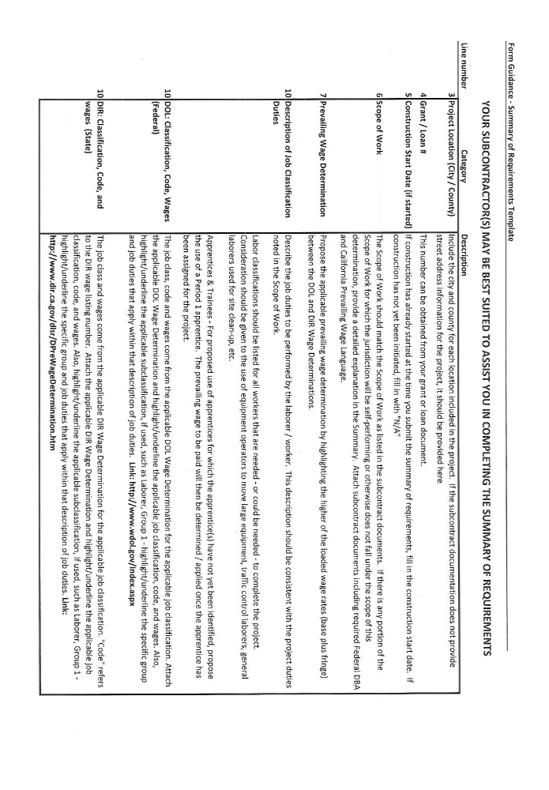
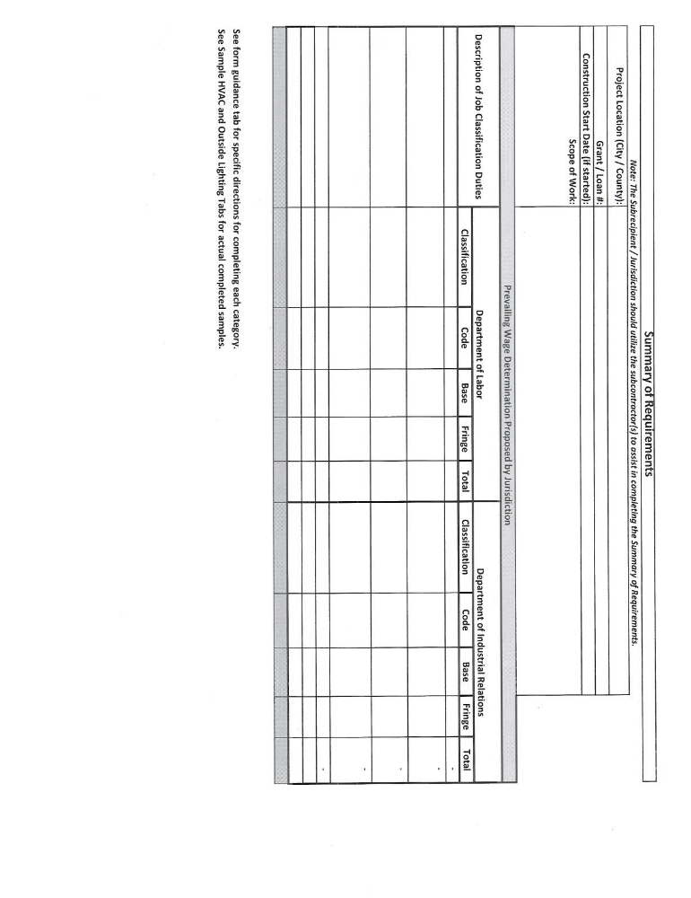

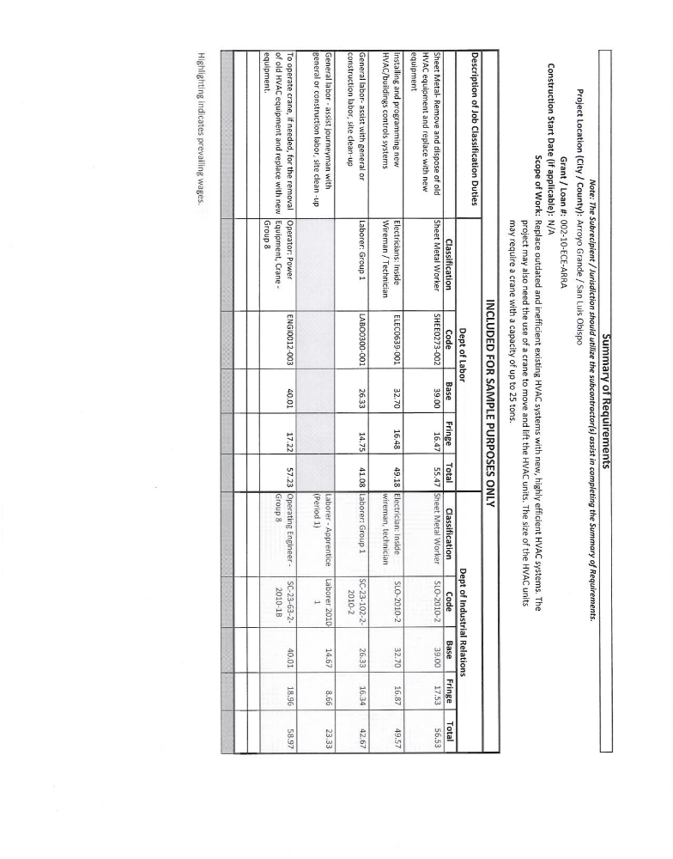

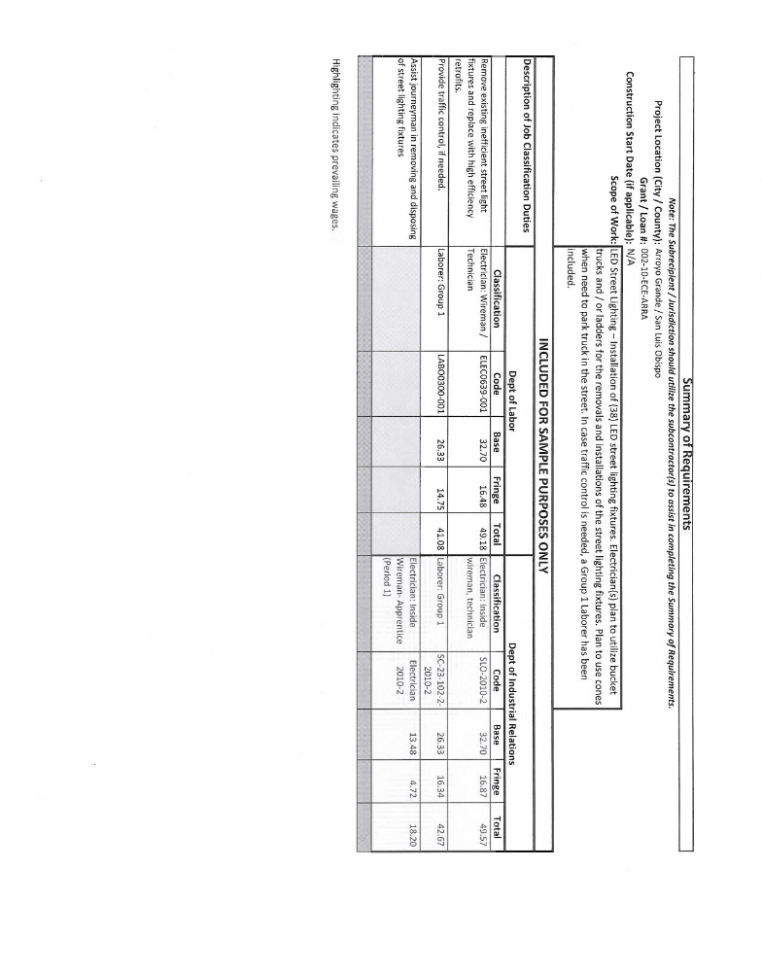

Wage and Hour Division (WHD)
Instructions For Completing Payroll Form, WH-347
WH-347 (PDF)
OMB Control No. 1215-0149, Expires 12/31/2011.
Persons are not required to respond to the collection of information unless it displays a currently valid OMB control number.
General: Form WH-347has been made available for the convenience of contractors and subcontractors required by their Federal or Federally-aided construction-type contracts and subcontracts to submit weekly payrolls. Properly filled out, this form will satisfy the requirements of Regulations, Parts 3 and 5 (29 C.F.R., Subtitle A), as to payrolls submitted in connection with contracts subject to the Davis-Bacon and related Acts.
While completion of Form WH-347 is optional, it is mandatory for covered contractors and subcontractors performing work on Federally financed or assisted construction contracts to respond to the information collection contained in 29 C.F.R. §§ 3.3, 5.5(a). The Copeland Act (40 U.S.C. § 3145) requires contractors and subcontractors performing work on Federally financed or assisted construction contracts to "furnish weekly a statement with respect to the wages paid each employee during the preceding week." U.S. Department of Labor (DOL) Regulations at 29 C.F.R. § 5.5(a)(3)(ii) require contractors to submit weekly a copy of all payrolls to the Federal agency contracting for or financing the construction project, accompanied by a signed "Statement of Compliance" indicating that the payrolls are correct and complete and that each laborer or mechanic has been paid not less than the proper Davis-Bacon prevailing wage rate for the work performed. DOL and federal contracting agencies receiving this information review the information to determine that employees have received legally required wages and fringe benefits.
Under the Davis-Bacon and related Acts, the contractor is required to pay not less than prevailing wage, including fringe benefits, as predetermined by the Department of Labor. The contractor's obligation to pay fringe benefits may be met either by payment of the fringe benefits to bona fide benefit plans, funds or programs or by making payments to the covered workers (laborers and mechanics) as cash in lieu of fringe benefits.
This payroll provides for the contractor to show on the face of the payroll all monies to each worker, whether as basic rates or as cash in lieu of fringe benefits, and provides for the contractor's representation in the statement of compliance on the payroll (as shown on page 2) that he/she is paying for fringe benefits required by the contract and not paid as cash in lieu of fringe benefits. Detailed instructions concerning the preparation of the payroll follow:

Contractor or Subcontractor: Fill in your firm's name and check appropriate box.
Address: Fill in your firm's address.
Payroll No.: Beginning with the number "1", list the payroll number for the submission.
For Week Ending: List the workweek ending date.
Project and Location: Self-explanatory.
Project or Contract No.: Self-explanatory.
Column 1 - Name and Individual Identifying Number of Worker: Enter each worker's full name and an individual identifying number (e.g., last four digits of worker's social security number) on each weekly payroll submitted.
Column 2 - No. of Withholding Exemptions: This column is merely inserted for the employer's convenience and is not a requirement of Regulations, Part 3 and 5.
Column 3 - Work Classifications: List classification descriptive of work actually performed by each laborer or mechanic. Consult classification and minimum wage schedule set forth in contract specifications. If additional classifications are deemed necessary, see Contracting Officer or Agency representative. An individual may be shown as having worked in more than one classification provided an accurate breakdown or hours worked in each classification is maintained and shown on the submitted payroll by use of separate entries.
Column 4 - Hours worked: List the day and date and straight time and overtime hours worked in the applicable boxes. On all contracts subject to the Contract Work Hours Standard Act, enter hours worked in excess of 40 hours a week as "overtime".
Column 5 - Total: Self-explanatory
Column 6 - Rate of Pay (Including Fringe Benefits): In the "straight time" box for each worker, list the actual hourly rate paid for straight time worked, plus cash paid in lieu of fringe benefits paid. When recording the straight time hourly rate, any cash paid in lieu of fringe benefits may be shown separately from the basic rate. For example, "$12.25/.40" would reflect a $12.25 base hourly rate plus $0.40 for fringe benefits. This is of assistance in correctly computing overtime. See "Fringe Benefits" below. When overtime is worked, show the overtime hourly rate paid plus any cash in lieu of fringe benefits paid in the "overtime" box for each worker; otherwise, you may skip this box. See "Fringe Benefits" below. Payment of not less than time and one-half the basic or regular rate paid is required for overtime under the Contract Work Hours Standard Act of 1962 if the prime contract exceeds $100,000. In addition to paying no less than the predetermined rate for the classification which an individual works, the contractor must pay amounts predetermined as fringe benefits in the wage decision made part of the contract to approved fringe benefit plans, funds or programs or shall pay as cash in lieu of fringe benefits. See "FRINGE BENEFITS" below.

Page 1 U.S. Department of Labor - Wage and Hour Division (WHD) - Instructions For Completi... of 2
http://www.dol.gov/whd/forms/wh347instr.htm 8/25/2011
Freedom of Information Act | Privacy & Security Statement | Disclaimers | Customer Survey | Important Web Site Notices | Plug-ins Used by DOL
U.S. Department of Labor | Frances Perkins Building, 200 Constitution Ave., NW, Washington, DC 20210
www.dol.gov | Telephone: 1-866-4-USWAGE (1-866-487-9243) | TTY: 1-877-889-5627 | Contact Us

Column 7 - Gross Amount Earned: Enter gross amount earned on this project. If part of a worker's weekly wage was earned on projects other than the project described on this payroll, enter in column 7 first the amount earned on the Federal or Federally assisted project and then the gross amount earned during the week on all projects, thus "$163.00/$420.00" would reflect the earnings of a worker who earned $163.00 on a Federally assisted construction project during a week in which $420.00 was earned on all work.
Column 8 - Deductions: Five columns are provided for showing deductions made. If more than five deduction are involved, use the first four columns and show the balance deductions under "Other" column; show actual total under "Total Deductions" column; and in the attachment to the payroll describe the deduction(s) contained in the "Other" column. All deductions must be in accordance with the provisions of the Copeland Act Regulations, 29 C.F.R., Part 3. If an individual worked on other jobs in addition to this project, show actual deductions from his/her weekly gross wage, and indicate that deductions are based on his gross wages.
Column 9 - Net Wages Paid for Week: Self-explanatory.
Totals - Space has been left at the bottom of the columns so that totals may be shown if the contractor so desires.
Statement Required by Regulations, Parts 3 and 5: While the "statement of compliance" need not be notarized, the statement (on page 2 of the payroll form) is subject to the penalties provided by 18 U.S.C. § 1001, namely, a fine, possible imprisonment of not more than 5 years, or both. Accordingly, the party signing this statement should have knowledge of the facts represented as true.
Items 1and 2: Space has been provided between items (1) and (2) of the statement for describing any deductions made. If all deductions made are adequately described in the "Deductions" column above, state "See Deductions column in this payroll." See "FRINGE BENEFITS" below for instructions concerning filling out paragraph 4 of the statement.
Item 4 FRINGE BENEFITS - Contractors who pay all required fringe benefits: If paying all fringe benefits to approved plans, funds, or programs in amounts not less than were determined in the applicable wage decision of the Secretary of Labor, show the basic cash hourly rate and overtime rate paid to each worker on the face of the payroll and check paragraph 4(a) of the statement on page 2 of the WH-347 payroll form to indicate the payment. Note any exceptions in section 4(c).
Contractors who pay no fringe benefits: If not paying all fringe benefits to approved plans, funds, or programs in amounts of at least those that were determined in the applicable wage decision of the Secretary of Labor, pay any remaining fringe benefit amount to
each laborer and mechanic and insert in the "straight time" of the "Rate of Pay" column of the payroll an amount not less than the predetermined rate for each classification plus the amount of fringe benefits determined for each classification in the application wage decision. Inasmuch as it is not necessary to pay time and a half on cash paid in lieu of fringe benefits, the overtime rate shall be not less than the sum of the basic predetermined rate, plus the half time premium on basic or regular rate, plus the required cash in lieu of fringe benefits at the straight time rate. In addition, check paragraph 4(b) of the statement on page 2 the payroll form to indicate the payment of fringe benefits in cash directly to the workers. Note any exceptions in section 4(c).
Use of Section 4(c), Exceptions
Any contractor who is making payment to approved plans, funds, or programs in amounts less than the wage determination requires is obliged to pay the deficiency directly to the covered worker as cash in lieu of fringe benefits. Enter any exceptions to section 4(a) or 4 (b) in section 4(c). Enter in the Exception column the craft, and enter in the Explanation column the hourly amount paid each worker as cash in lieu of fringe benefits and the hourly amount paid to plans, funds, or programs as fringe benefits. The contractor must pay an amount not less than the predetermined rate plus cash in lieu of fringe benefits as shown in section 4(c) to each such individual for all hours worked (unless otherwise provided by applicable wage determination) on the Federal or Federally assisted project. Enter the rate paid and amount of cash paid in lieu of fringe benefits per hour in column 6 on the payroll. See paragraph on "Contractors who pay no fringe benefits" for computation of overtime rate.
Public Burden Statement: We estimate that it will take an average of 55 minutes to complete this collection of information,including time for reviewing instructions, searching existing data sources, gathering and maintaining the data needed, and completing and reviewing the collection of information. If you have any comments regarding these estimates or any other aspect of this collection of information, including suggestions for reducing this burden, send them to the Administrator, Wage and Hour Division, ESA, U.S. Department of Labor, Room S3502, 200 Constitution Avenue, N.W.,Washington, D.C. 20210.
Note: In order to view, fill out, and print PDF forms, you need Adobe® Acrobat® Reader® version 5 or later, which you may download for free at www.adobe.com/products/acrobat/readstep2.html. To save the completed forms on your workstation, you need to use the "Save As" method to save the file.
For example, move your mouse curser over the PDF link and click on your "RIGHT" mouse button. This will cause a menu to be displayed, from which you will select the proper save option -- depending upon which browser you are using:
For Microsoft IE users, select "Save Target As"
For Netscape Navigator users, select "Save Link As"
Once you've selected the proper save option for your browser, and have saved the file to a location you specified, go to your program
menu and start the Adobe Acrobat® Reader. Once open, locate the PDF file you saved and open it directly in Acrobat®.

Page 2 U.S. Department of Labor - Wage and Hour Division (WHD) - Instructions For Completi... of 2
http://www.dol.gov/whd/forms/wh347instr.htm 8/25/2011



